Overview of DAEMOT Library Blocks

# Components

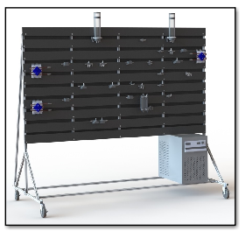

## Nomenclature

Fld – Fluid type

T_init – Initial fluid temperature

h_init – Initial fluid height

M_init – Initial fluid mass

P_init – Initial fluid pressure

Tamb_init – Initial ambient temperature

H – Heat transfer coefficient (or pump head)

D – Diameter

Pamb – Ambient pressure

A_cross – Cross-sectional area

Cp – Specific heat

g – Gravitational acceleration

T – Fluid outlet temperature

P – Fluid outlet pressure

A_ht – Heat transfer area

T_dot – Temperature derivative

P_dot – Pressure derivative

t – Tube wall thickness

E – Tube modulus of elasticity

v – Tube Poisson ratio

V – Volume

dP – Pressure differential

Q – Volumetric flow rate

KL – Minor loss coefficient

e_rough – Tube surface roughness

f – Tube friction factor

dH – Height difference between inlet and outlet (negative if inlet is lower than outlet)

Tw – Heat exchanger wall temperature

M_wall – Mass of wall of heat exchanger

Cp_wall – Specific heat of wall of heat exchanger

b – Plate spacing in heat exchanger

W – Width of heat exchanger

L – Length of heat exchanger

## Tank

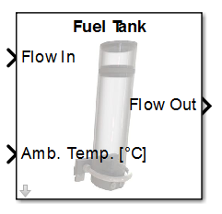

* This component models a single-phase tank.
* Given the tank pressure, the tank height and mass are calculated by:  and 
* The tank fluid temperature is calculated by: , where  is the heat transfer area and  is the heat transfer coefficient. This equation comes from the following derivation:  
  
* The tank pressure is calculated by:  where  is the cross-sectional area of the tank. This equation comes from the following derivation:
* For the purposes of initialization only, the pressure and tank mass are calculated from the initial tank height by:  and  where  is calculated as a function of the initial temperature but assumes an initial tank pressure.

## Pump

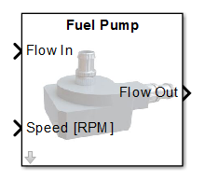

* This component models a single-phase pump.
* The outlet temperature is calculated as: 
* The outlet pressure is calculated as: 
* The head achieved by the pump is calculated by:  where the coefficients  are found using experimental data and  is the duty ratio of the pump, 
* The volumetric flow rate is calculated as:  where  is the area at the exit of the pump and 
* The mas flow rate of the pump is calculated by: 
* The percent efficiency of the pump is calculated by: 

where the coefficients  are found using experimental data and .

* The electrical power consumption by the pump is calculated by: .

## Split/Junction (with Dynamics)

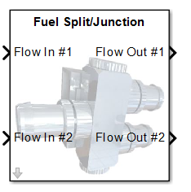

* This component splits and junctions flows using dynamic relationships.
* The pressure is calculated as: 
* The outlet temperature is calculated as: .
* Note that the library link of the block is disabled when it is imported into a model.

## Pipe (P to m) (Dynamic)

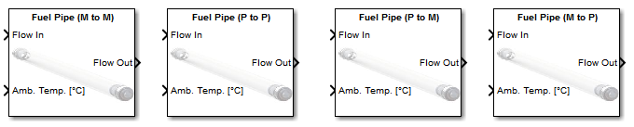

* This pipe calculates a dynamic outlet pressure and an algebraic inlet mass flow rate.
* The mass flow rate is calculated as:  where  is the cross sectional area and  is the mean fluid velocity which is calculated as , pressure in Pa.
* The outlet pressure is calculated as: 
* The outlet temperature is calculated as: 

## Pipe (P to P) (Static)



* This pipe calculates an algebraic mass flow rate between the pressures of neighboring components.
* The mass flow rate is calculated as:  where  is the cross sectional area and  is the mean fluid velocity which is calculated as , pressure in Pa.
* The outlet temperature is calculated as: 

## Cold Plate

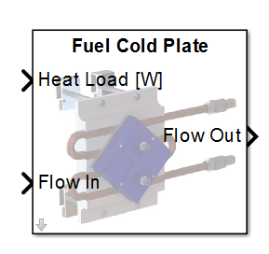

* This component models single-phase flow through a cold plate under a heat load.
* The mass flow rate is calculated as:  where  is the cross sectional area and  is the mean fluid velocity which is calculated as , pressure in Pa.
* The outlet pressure is calculated as: 
* The wall temperature (lumped to represent the average wall temperature of the component) is calculated as: 
* The outlet temperature is calculated as: 

where  is the heat transfer area and  is the heat transfer coefficient calculated from the Nusselt Number.

## Heat Exchanger

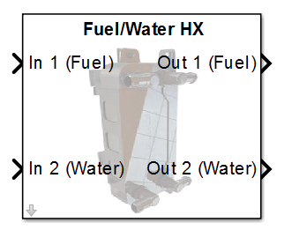

* This component models a single-phase plate heat exchanger.
* The mass flow rate of a single pass for each side is calculated as:  where  is the cross sectional area and  is the mean fluid velocity which is calculated as , pressure in Pa, and  is the hydraulic diameter.
* The outlet pressure for each side is calculated as:  where  and  are the mass flow rates and volumes for a single pass
* The wall temperature (lumped to represent the average wall temperature of the component) is calculated as: , where  is the mass of a single plate
* The outlet temperature of each side is calculated as: 

where  is the heat transfer area and  is the heat transfer coefficient calculated from the Nusselt Number.

## Old Components

## Static Flow Split

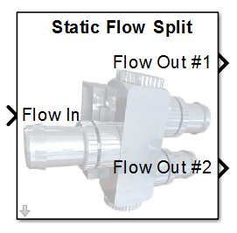

* This component splits an inlet flow into multiple exit flows using static relationships. The number of outlet flows is a mask parameter, and changing it causes blocks under the mask to be added/removed/connected/etc. as needed to support this.
* Mass flow rates are taken from the downstream blocks.
* The inlet mass flow rate is calculated as: .
* The outlet temperature is calculated as: 
* The outlet pressure is calculated as: 
* Note that the library link of the block is disabled when it is imported into a model.
* Note that multiple inlet and multiple outlet flows can be all connected together by connecting a Flow Junction block in series with a Flow Split block.

## Static Flow Junction

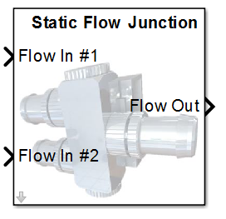

* This component combines multiple inlet flow into a single exit flow using static relationships. The number of inlet flows is a mask parameter, and changing it causes blocks under the mask to be added/removed/connected/etc. as needed to support this.
* Mass flow rates are taken from the upstream blocks.
* The outlet mass flow rate is calculated as: .
* The outlet temperature is calculated as: .
* The outlet pressure is calculated as: 
* Note that the library link of the block is disabled when it is imported into a model.
* Note that multiple inlet and multiple outlet flows can be all connected together by connecting a Flow Junction block in series with a Flow Split block.

## Drain Pump

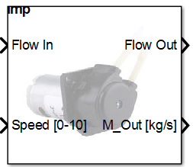

* This component uses the inlet (upstream block) pressure and the drain pump speed (0-10) to determine the mass flow rate out.
* Pressure is taken from upstream block.
* Outlet mass flow rate is sent to upstream block.
* Temperature and pressure from upstream are passed through. Mass flow rate from upstream block is ignored.
* Pressure and drain pump speed mapping to outlet mass flow rate was done in “Peristaltic Pump Flow Rates New Config.xlsx” file. These maps are specifically for drain pump 1 and drain pump 2 working together and operating at the same speed.

## Pipe (Old)



* The pipe models can be used to calculate either a pressure or a mass flow rate for the upstream and downstream blocks.
* Four variants exist for use with different types of upstream and downstream blocks. The ‘M to M’ variant should be used when both the upstream and downstream blocks calculate a mass flow rate. The ‘P to P’ variant should be used when both the upstream and downstream blocks calculate a pressure. The ‘P to M’ variant should be used when the upstream block calculates a pressure and the downstream block calculates a mass flow rate. Lastly, the ‘M to P’ variant should be used when the upstream block calculates a mass flow rate and the downstream block calculates a pressure.
* The outlet temperature is calculated as: . This may be modified in future versions to include a first order response, delay, etc. in the outlet temperature response. While the ambient temperature has been made an input to the block to support this future update, the ambient temperature is not currently used in the block.
* In the ‘M to M’ variant, the pressure (lumped to represent the average pressure of the component) is calculated as:  and the inlet and outlet pressures are calculated as:  and , where 
* In the ‘P to P’ variant, the mass flow rate is calculated as: , where  and 
* In the ‘M to P’ and ‘P to M’ variants, the mass flow rate is assumed to be constant across the length of the pipe (equal to the mass flow rate provided by the upstream or downstream block, respectively). Pressure drops are calculated as: 

## Flow Source

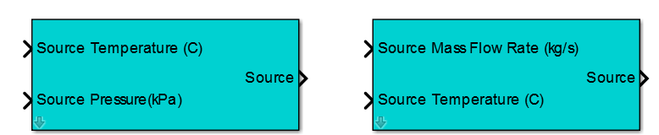

* This block is used to create a flow source. There are two variants: One that provides a pressure to the downstream block, and one that provides a mass flow rate to the downstream block.

## Flow Sink

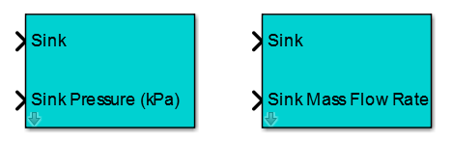

* This block is used to create a flow sink. There are two variants: One that provides a pressure to the upstream block, and one that provides a mass flow rate to the upstream block.

# Support Functions

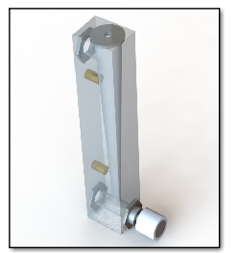

## Data Manager

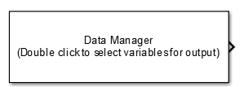

* This block can be used to access data from within any component model in a diagram.

## Data_Sink

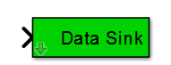

* This block is used internally in component models to make data available to the Data Manager bock.

## Sink

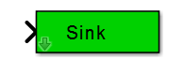

* This block is used internally in component models to sink data to upstream components.

## Source

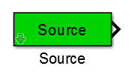

* This block is used internally in component models to source data from upstream components.

## Unit Conversion

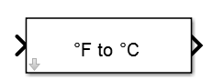

* This block can be used for unit conversion of signals, including units of mass, density, energy, power, force, temperature, pressure, length, area, volume, velocity, and flow rate.